Automatic Garden Plant Watering System Using STM32F407G-DISC1
Below are the peripherals you will use and a clean roadmap you can follow step-by-step to finish the project.

✅ 1. Peripherals Required (with purpose)
🔸 1. GPIO (Digital Input/Output)
Used for:
- Driving relay/MOSFET for water pump
- Reading float switch (tank empty)
- Reading manual push button (override ON/OFF)
- Reading rain sensor (digital type)
✔ Essential peripheral

🔸 2. ADC (Analog-to-Digital Converter)
Used for:
- Reading soil moisture sensor (capacitive analog type recommended)
- Reading water level sensor (optional)
- Reading potentiometer for threshold setting (optional)
✔ ADC1 or ADC3 on pins like PA0, PA1, PB0, PC1 etc.

🔸 3. TIMERS (General Purpose Timers)
Use two types:
A. Delay timer
- For periodic moisture checking (1 sec, 5 sec, etc.)
- For pump run time measurement
B. PWM timer (optional)
To control:
- Pump speed (if DC pump supports PWM)
- Valve position (servo)
Examples:
- TIM2 (32-bit, perfect for precise delays)
- TIM3/TIM4 for PWM (DISC1 LEDs are on TIM4)

🔸 4. UART (Serial communication)
Used for:
- Printing moisture value
- Debugging
- Changing threshold via terminal
- Connecting Bluetooth module (HC-05)
UART2 is easiest (connected to ST-LINK Virtual COM Port).

🔸 5. RTC (Real-Time Clock)
Used when you need scheduled watering:
- Water at 7 AM daily
- Water every 48 hours
- Skip watering at night
STM32F407 has built-in RTC module.
(Needs a coin cell battery).

🔸 6. I2C (Optional but recommended)
Used for:
- LCD 16×2 I2C
- OLED display
- External RTC like DS3231

🔸 7. EXTI (Interrupts)
Used for:
- Float switch emergency stop
- Rain detector interrupt
- Manual button press
- Watchdog timer triggers

🔸 8. Watchdog Timer (Recommended for reliability)
Used to restart system if stuck.
Useful for long-running outdoor systems.

⭐ Summary of Peripherals Used
Peripheral | Purpose
GPIO | Pump, rain sensor, float switch, buttons
ADC | Soil moisture, water level
Timer | Periodic tasks, pump timing, PWM
PWM | Pump speed / valve control (optional)
UART | Serial debug / Bluetooth
I²C | LCD/OLED / External RTC (optional)
RTC | Scheduled watering
EXTI | Emergency stop, buttons
Watchdog | System reliability

🌱 2. Roadmap for the Project (Step-by-Step)

⭐ STEP 1: Basic Setup (Day 1)
- Install STM32CubeIDE
- Test LED blinking (verify code works)
- Enable UART for debugging (printf to serial monitor)
📌 Outcome: Board is ready for development.

⭐ STEP 2: Soil Moisture Sensing (ADC)
- Connect capacitive soil moisture sensor to ADC pin (e.g., PA0)
- Read ADC value
- Convert to percentage moisture
- Apply simple filtering (average of 10 samples)
📌 Outcome: System can measure soil moisture accurately.

⭐ STEP 3: Drive Water Pump (GPIO + MOSFET/Relay)
- Build pump driver using IRLZ44N MOSFET or relay module
- Add flyback diode (for DC pump)
- Control ON/OFF using GPIO pin
Add float switch (tank empty safety)
- If float switch = LOW → stop pump.
📌 Outcome: STM32 can control pump safely.

⭐ STEP 4: Automatic Watering Logic
Implement basic hysteresis:
if (moisture < 40%) → pump ON
if (moisture > 60%) → pump OFF
Add safety:
- Float switch
- Rain sensor
- Minimum ON time (e.g., 5 sec)
- Minimum OFF time (e.g., 60 sec)
📌 Outcome: System waters automatically based on moisture.

⭐ STEP 5: Add Timers (for periodic checks)
- Check moisture every 2 seconds
- Limit pump running time
- Use TIM2 or SysTick
📌 Outcome: Smooth timing-based operation.

⭐ STEP 6: Add Display / User Interface (Optional)
Using I2C:
- Show soil moisture
- Pump ON/OFF status
- Tank empty alarm
- Set threshold using buttons
📌 Outcome: User can see real-time status.

⭐ STEP 7: Add RTC for Scheduled Watering
- Use STM32 RTC or DS3231
- Water only in morning/evening
- Add "skip watering if raining"
📌 Outcome: Intelligent watering system.

⭐ STEP 8: Add Bluetooth / Wi-Fi (Optional)
- Control via phone
- Send moisture data
- Receive pump ON/OFF commands
📌 Outcome: Smart, modern system.

⭐ STEP 9: Long-Term Reliability
- Use watchdog timer
- Use fuses and TVS protection
- Add IP56 waterproof enclosure
📌 Outcome: Can run in outdoor conditions 24×7.

🌟 Final System Features (What You Will Achieve)
Your final project will:
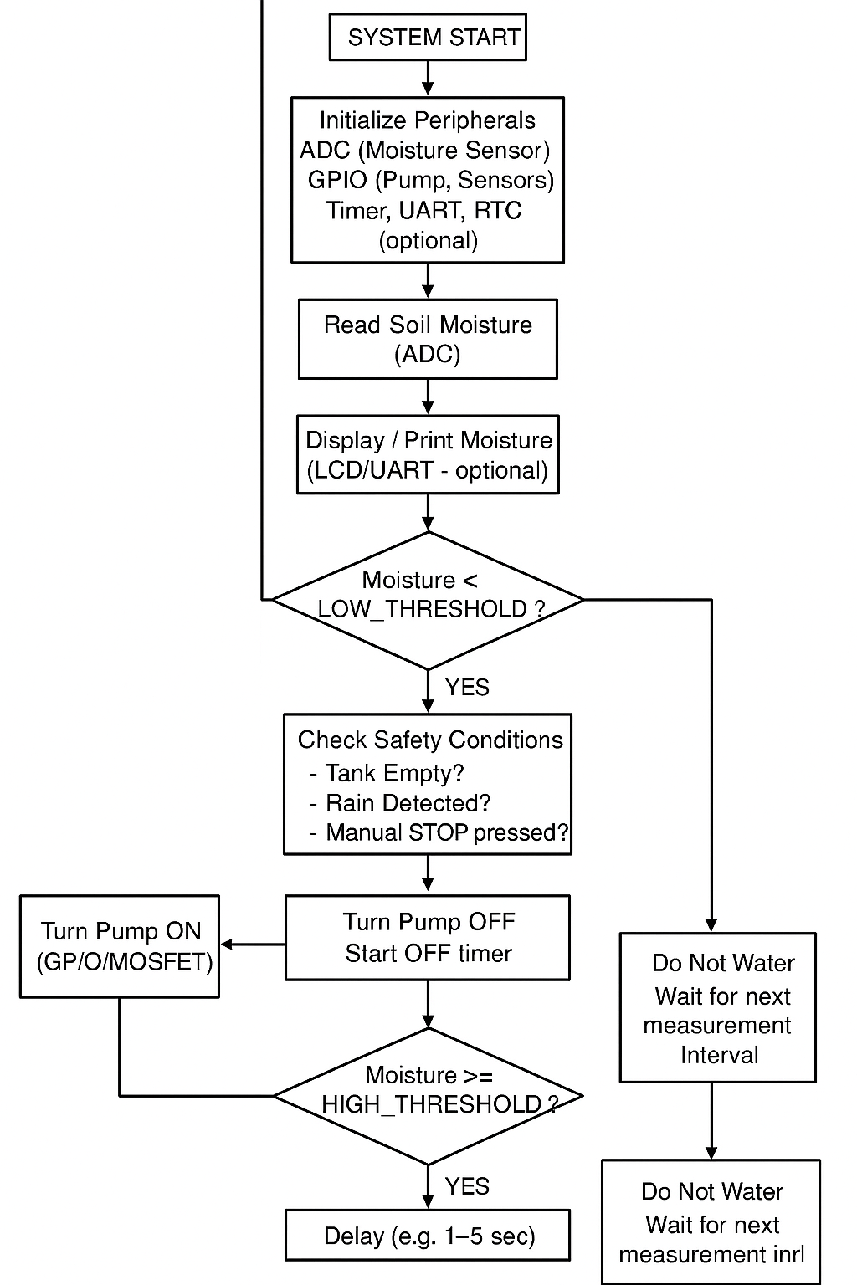
✔ Measure soil moisture
✔ Water plants automatically
✔ Protect pump (tank empty detection)
✔ Avoid watering when raining
✔ Run on schedule (morning/evening)
✔ Show real-time status
✔ Handle emergencies
✔ Run months without failure

